**Second Project Report**

***Name: - Shyam Sagar Singh Choudhary***

***Batch: 67***

**Project Title: - Netflix Clone**

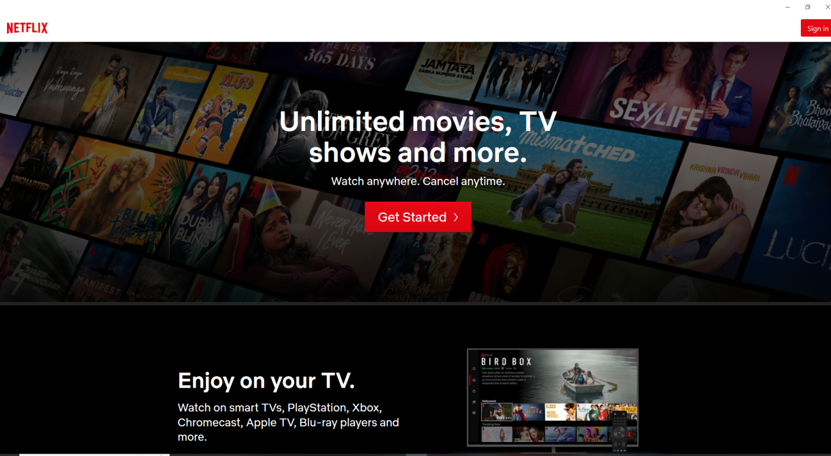**Project Sample:-**

**Introduction:-**

Netflix is **​​a** subscription-based streaming service that allows members to watch TV shows and movies on **any** internet-connected device.

Here I am going to design a clone of Netflix as my project.

**Technologies :-**

1. **Front end:**
   1. **Html**
   2. **CSS**
   3. **Bootstrap**
   4. **React js**
2. **Back end:-**
   1. **Node +Express**
3. **Database:-**
   1. **Mongo DB**

**Git Link:-**